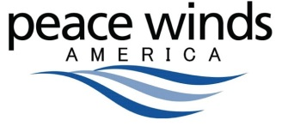
Peace Winds America Donation Form
2341 Eastlake Ave. E, Suite 001
Seattle, WA 98102
206.432.3712
www.peacewindsamerica.org

YES! I/We would like to help develop an integrated and efficient disaster response to save lives and reduce economic losses. Please choose one of the giving options listed below.

[Option 1] Enclosed is my ONE TIME DONATION of:

□ $60 □ $100 □ $300 □ $500 □ $1,000 □ Other / $
□ Enclosed is my check, made payable to Peace Winds America.

□ Please charge my credit card: ○ Visa ○ Mastercard ○ American Express

Card #: CVV2:

Name on Card: Exp. Date:

[Option 2] Enclosed is my MONTHLY DONATION of:

□ $15 □ $30 □ $60 □ $100 □ $300 □ Other / $
□ I authorize PWA to charge my credit or debit card each month:
○ Visa ○ Mastercard ○ American Express

Card #: CVV2:

Name on Card: Exp. Date:

Your Information (please fill in your information below):

Name(s):

Address:

Preferred Phone (please circle one - Home/Work/Cell):

Email Address(es):

Please accept my gift in □ honor of □ memory of:

Please send this form to Peace Winds America:
Email: info@peacewindsamerica.org
Mail: 2341 Eastlake Ave. E, Suite 001, Seattle, WA 98102
Or make your gift online: http://peacewindsamerica.org/support-pwa/relief-and-recovery-giving/

PWA is a 501(c)(3) organization (Tax ID (EIN): 26-3744952).
Donations are tax deductible to the extent allowed by law.

